STAT 8120 – Module 10 Homework

Due 4/26/2020

Connor Armstrong

***14.3*** *A manufacturing engineer is studying the dimensional variability of a particular component that is produced on three machines. Each machine has two spindles, and four components are randomly selected from each spindle. The results follow. Analyze the data, assuming that machines and spindles are fixed factors.*

An inspection of the experimental layout reveals that **the factor spindle is nested under the factor machine** because each spindle can be relabeled ie 1-6 instead of 1-2 for each machine. The experimental design is **not a crossed layout** because each spindle, under each machine, has its own 4 respective observations. This design is also called a balanced 3 x 2 Hierarchical Design. There is no interaction term to be analyzed because machine*spindle because machine and spindle are not crossed at all treatment levels. The data was analyzed using the balanced ANOVA function in Minitab. The ANOVA table and residual analysis follow.

**Analysis of Variance for Variability**

|  |  |  |  |  |  |
| --- | --- | --- | --- | --- | --- |
| **Source** | **DF** | **SS** | **MS** | **F** | **P** |
| Machine | 2 | 55.75 | 27.875 | 18.93 | 0.000 |
| Spindle(Machine) | 3 | 43.75 | 14.583 | 9.91 | 0.000 |
| Error | 18 | 26.50 | 1.472 |  |  |
| Total | 23 | 126.00 |  |  |  |

* Both factors Spindle and Machine have significant p-values. Therefore, subject to validation of the assumptions, the factors Spindle and Machine have a significant effect on the dimensional variability of the components.

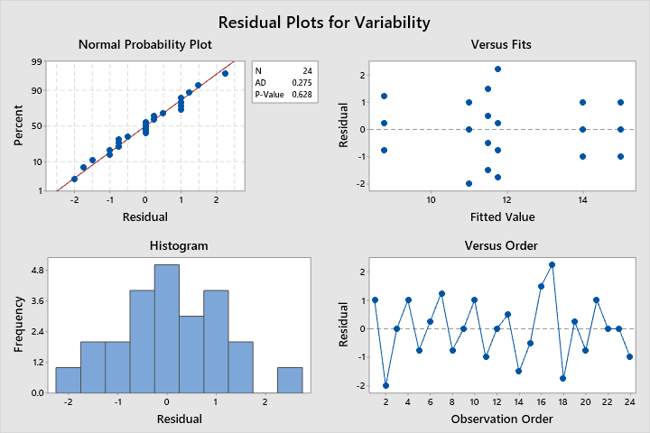

* The A.D. normality test p-value is 0.628, which satisfies the normality assumption.
* Without run-order information, the independence assumption will remain unverified.
* One observation has a standardized residual greater than 2, but is not of concern as an outlier.
* Both factors pass Levene’s test of homogeneity of variance with respect to the response, Variability. The p-value for the factor spindle is marginal. This may be cause for further investigation.

**Fits and Diagnostics for Unusual Observations**

|  |  |  |  |  |  |
| --- | --- | --- | --- | --- | --- |
| **Obs** | **Variability** | **Fit** | **Resid** | **Std Resid** |  |
| 17 | 14.000 | 11.750 | 2.250 | 2.14 | R |

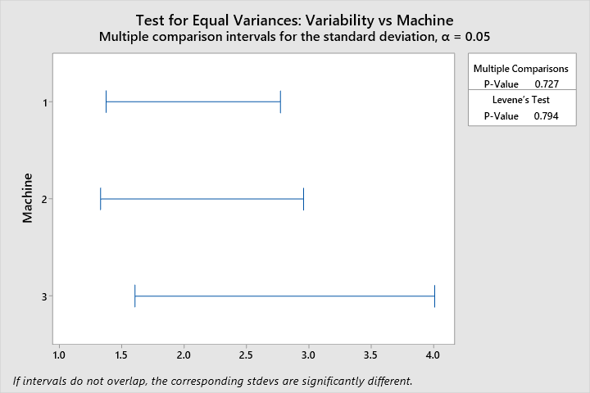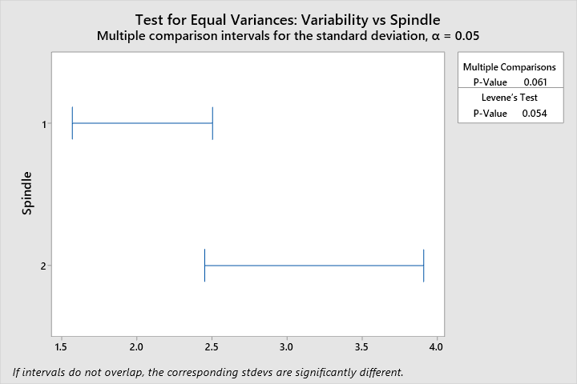

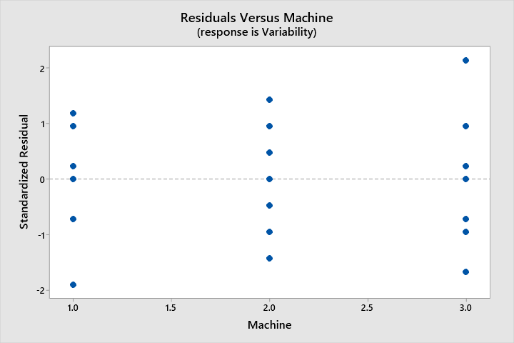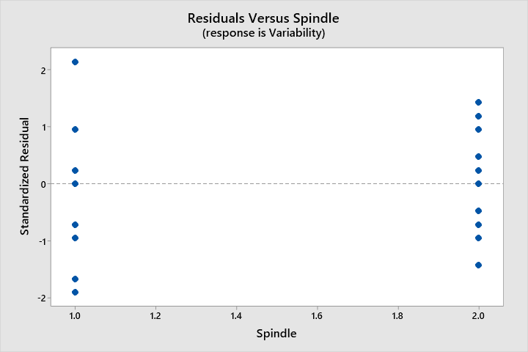

***14.19*** *Steel is normalized by heating above the critical temperature, soaking, and then air cooling. This process increases the strength of the steel, refines the grain, and homogenizes the structure. An experiment is performed to determine the effect of temperature and heat treatment time on the strength of normalized steel. Two temperatures and three times are selected. The experiment is performed by heating the oven to a randomly selected temperature and inserting three specimens. After 10 minutes one specimen is removed, after 20 minutes the second is removed, and after 30 minutes the final specimen is removed. Then the temperature is changed to the other level and the process is repeated. Four shifts are required to collect the data, which are shown below. Analyze the data and draw conclusions, assuming both factors are fixed.*

This experiment consists of a split plot design, and the experiment is not completely randomized. “Temperature” is the whole plot treatment, and is therefore confounded with the plot, or replicate, factor “Shifts.” The factor “Time” is the subplot factor for this experiment and is therefore not confounded with other factors. The factor “Shift” will be designated as a random factor. The data was analyzed in Minitab using the (restricted model) Balanced ANOVA function for Split-Plots procedure detailed in the Module 10 study guide, S8120SG14d122417.pdf. The ANOVA table, discussion, and residual analysis begins on page 3.

**Analysis of Variance**

|  |  |  |  |  |  |  |
| --- | --- | --- | --- | --- | --- | --- |
| **Source** | **DF** | **Adj SS** | **Adj MS** | **F-Value** | **P-Value** |  |
| Shift | 3 | 145.5 | 48.49 | 0.41 | 0.757 | x |
| Temperature | 1 | 2340.4 | 2340.38 | 29.20 | 0.012 |  |
| Shift*Temperature | 3 | 240.5 | 80.15 | 1.97 | 0.220 |  |
| Time | 2 | 159.2 | 79.62 | 1.00 | 0.422 |  |
| Shift*Time | 6 | 478.4 | 79.74 | 1.96 | 0.217 |  |
| Time*Temperature | 2 | 795.3 | 397.63 | 9.76 | 0.013 |  |
| Error | 6 | 244.4 | 40.74 |  |  |  |
| Total | 23 | 4403.6 |  |  |  |  |

*x Not an exact F-test.*

**Expected Mean Squares, using Adjusted SS**

|  |  |  |
| --- | --- | --- |
|  | **Source** | **Expected Mean Square for Each Term** |
| 1 | Shift | (7) + 2.0000 (5) + 3.0000 (3) + 6.0000 (1) |
| 2 | Temperature | (7) + 3.0000 (3) + Q[2, 6] |
| 3 | Shift*Temperature | (7) + 3.0000 (3) |
| 4 | Time | (7) + 2.0000 (5) + Q[4, 6] |
| 5 | Shift*Time | (7) + 2.0000 (5) |
| 6 | Time*Temperature | (7) + Q[6] |
| 7 | Error | (7) |

**Error Terms for Tests, using Adjusted SS**

|  |  |  |  |  |
| --- | --- | --- | --- | --- |
|  | **Source** | **Error DF** | **Error MS** | **Synthesis of Error MS** |
| 1 | Shift | 4.08 | 119.1528 | (3) + (5) - (7) |
| 2 | Temperature | 3.00 | 80.1528 | (3) |
| 3 | Shift*Temperature | 6.00 | 40.7361 | (7) |
| 4 | Time | 6.00 | 79.7361 | (5) |
| 5 | Shift*Time | 6.00 | 40.7361 | (7) |
| 6 | Time*Temperature | 6.00 | 40.7361 | (7) |

**Variance Components, using Adjusted SS**

|  |  |  |  |  |
| --- | --- | --- | --- | --- |
| **Source** | **Variance** | **% of Total** | **StDev** | **% of Total** |
| Shift | -11.7778* | 0.00% | 0.00000 | 0.00% |
| Shift*Temperature | 13.1389 | 17.91% | 3.62476 | 42.32% |
| Shift*Time | 19.5 | 26.58% | 4.41588 | 51.55% |
| Error | 40.7361 | 55.52% | 6.38248 | 74.51% |
| Total | 73.375 |  | 8.56592 |  |

*\* Value is negative, and is estimated by zero.*

* Minitab produces the correct F-test for the whole plot factor, temperature, the subplot factor, time, and the temperature*time interaction.
* Because there is no three-factor interaction, it becomes error.

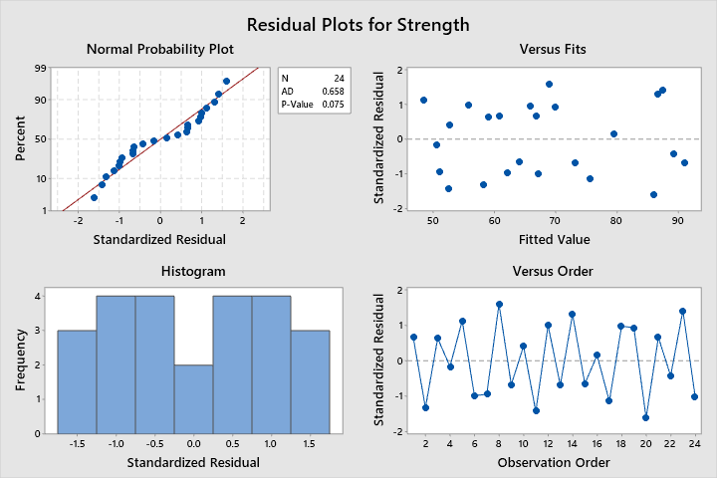

* The Normality test is questionable, having a p-value of 0.075 for the A.D. normality test.
* There are no observations outside 2 standard deviations from their respective expected values. Therefore, no outliers.
* Without overall run-order information, the independence assumption will remain unverified.
* The factors Temperature and Shift pass Levene’s test of homogeneity of variance with respect to Strength. The factor Time does not pass Levene’s test of homogeneity of variance.

